Authentication = Login
Authorization = A sti ce actiuni poate face un user si ce actiuni ii sunt interzise

19. Restrinting endpoints with Roles "
The role is just a bunch of permissions grouped together.
A role is just a business level representation of our user:
super admin,
admin,
somebody with moderation rights

Roles = to package up a litle behave you're in a single thing to keep JWT as compact as possible.
That's why the standard JWT claim names are just three letters.

Putem crea o politica in

SwaggerJwtInstaller.cs

builder.Services.AddAuthorization ();

DbInstaller.cs

services.AddDefaultIdentity<IdentityUser>()
.AddRoles<IdentityRole>()
.AddEntityFrameworkStores<DataContext>();

.AddRoles<IdentityRole>() - this will automatically add the role manager in DI for the identity role

Ambele clase IdentityUser si IdentityRole pot fi extinse si customizate.

Program.cs

await dbContext.Database.MigrateAsync();

var roleManager = serviceScope.ServiceProvider.GetRequiredService<RoleManager<IdentityRole>>();

[ApiController]
[Authorize(AuthenticationSchemes = JwtBearerDefaults.AuthenticationScheme,
Roles = "Admin,Poster")]
public class FlowersController : ControllerBase
{
}

Combinand roluri, se pot obtine policy:

SwaggerJwtInstaller.cs

builder.Services.AddAuthorization (options => {
options.AddPolicy("Test", policy => policy.RequireRole("Admin, Poster"))
});

AspNetUsers | AspNetRoles
Email: admin@test.com  Id: 71e2eb19-17ad-43a9-90c8-0ea2442ce80f | Name: Admin  Id: af1466a2-583b-4991-8b5d-6e9c2eee7006
Email: poster@test.com  Id: d09f5461-7a53-4ae8-b265-9d376366e931 | Name: Poster  Id: dcc7eaab-d2c1-4049-bfe6-d1a1f3e6b2bc

AspNetUserRoles – am populat-o manual

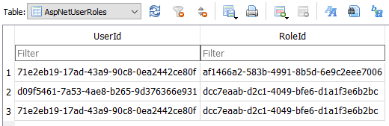

Identity  POST /api/v1/identity/login  Request body  {  "email": "admin@test.com",  "password": "**********"  }  Response body  {{  "token": "...",  "refreshToken": "..."  } | jwt.ms  